**Case 12-US-AK-Yu'pik-Umiak-1900 CE**

**Yupik**, **Yupiit** or **Western Eskimo**, in Siberia, Saint Lawrence Island and the [Diomede Islands](https://www.britannica.com/place/Diomede-Islands) in the [Bering Sea](https://www.britannica.com/place/Bering-Sea) and [Bering Strait](https://www.britannica.com/place/Bering-Strait), and Alaska. They are culturally related to the [Chukchi](https://www.britannica.com/topic/Chukchi) and the Inuit, or Eastern [Eskimo](https://www.britannica.com/topic/Eskimo-people), of Canada and Greenland.

The traditional economic activity of the Yupik was the hunting of sea mammals, especially seals, walrus, and, until the latter half of the 19th century, whales.

Hunting fur-bearing animals, fishing, and collecting plant food were auxiliary activities. Kayaks (one-person, closed skin boats), Umiak (open, flat-bottomed boats),

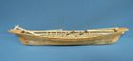

and whaleboats provided coastal transportation; dog teams and sleds were used on land.

Trade with the Russians developed at the end of the 19th century. The Yupik also traded with neighboring reindeer breeders and others. Some enterprising Yupik specialized in trade and used their economic advantage to become village chiefs, with such functions as opening and closing the hunting season, helping to mediate quarrels, and deciding the times for trade journeys. Hunting methods included harpooning from shore or boats, spearing animals in land drives, and, later, the use of guns.

The Yupik practiced shamanism and believed in benign and harmful spirits; the latter caused various misfortunes, especially illness.

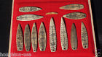

Engraved Reindeer Antler Shaman Talismans, Prehistoric. Certain animals and birds were (and still are) considered sacred and not to be harmed. Rituals, mainly connected with ensuring future success in hunting and with thanksgiving for past hunts, often included dramatic performances and dances. Women generally played an important part in religious rituals.

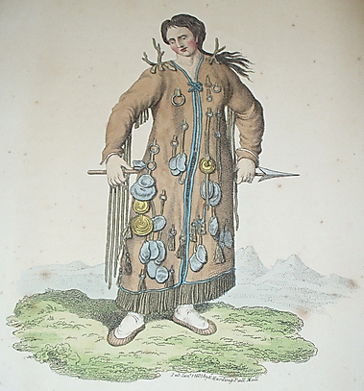

**1802 Hand Watercolor Prints of a Siberian Yupik Inuit Shaman wearing a robe decorated with mirrors**

**E. Harding Pall Mall**